Create a GUI application for user registration.

1.User should be able to fill all details.Application must check all the validation of data (email is in proper format ,name has only letter etc).User must be able to Submit the form if all data is valid and after submit display “control number:” to user using message box and that too should be save in database.

2.Forgot passwd form of application should create a new passwd if user request but after valid “control number” input by the user

**Solution:**

Imports System.Data.SqlClient

Imports System.Data

Imports System.Configuration

Public Class Registration

Dim conString As String = "Data Source=.\SQLEXPRESS;AttachDbFilename=C:\Users\ktrim\Documents\registrationdb.mdf;Integrated Security=True;Connect Timeout=30;User Instance=True"

Dim con As New SqlConnection

Dim cmd As New SqlCommand

Dim dr As SqlDataReader

Private Sub btnsubmit_Click(sender As System.Object, e As System.EventArgs) Handles btnsubmit.Click

If (txtpasswd.Text = txtrepasswd.Text) Then

If (txtemail.Text.Contains("@") And txtemail.Text.Contains(".") And txtemail.Text.Contains("com")) Then

con.ConnectionString = conString

cmd.Connection = con

con.Open()

cmd.CommandText = "insert into registration_table values('" & txtusername.Text & "','" & txtpasswd.Text & "','" & txtrepasswd.Text & "','" & txtemail.Text & "','" & txtphoneno.Text & "','" & txtaddress.Text & "')"

cmd.ExecuteNonQuery()

MsgBox("User created Sucessfully")

Dim query As String = "select @@IDENTITY"

cmd.CommandText = query

Dim Controlno As Integer = cmd.ExecuteScalar()

MsgBox("Your Control No." & Controlno.ToString())

con.Close()

Login.Show()

Else

MsgBox("Email not valid")

End If

Else

MsgBox("Both passwd must be same")

End If

End Sub

End Class

Imports System.Data.SqlClient

Imports System.Data

Imports System.Configuration

Public Class Recover_Passwd

Dim conString As String = "Data Source=.\SQLEXPRESS;AttachDbFilename=C:\Users\ktrim\Documents\registrationdb.mdf;Integrated Security=True;Connect Timeout=30;User Instance=True"

Dim con As New SqlConnection

Dim cmd As New SqlCommand

Dim ds As New DataSet

Dim dt As New DataTable

Private Sub btnreset_Click(sender As System.Object, e As System.EventArgs) Handles btnreset.Click

con.ConnectionString = conString

cmd.Connection = con

con.Open()

cmd.CommandText = "select * from registration_table where username='" & txtusername.Text & "' and user_id='" & txtcontrolno.Text & "'"

Dim da As New SqlDataAdapter(cmd)

da.Fill(ds)

con.Close()

If (ds.Tables(0).Rows.Count <> 0) Then

txtpasswd.Visible = True

txtrepasswd.Visible = True

Label3.Visible = True

Label4.Visible = True

btnsave.Visible = True

Else

MsgBox("your username or control number is invalid!....")

End If

End Sub

Private Sub Recover_Passwd_Load(sender As System.Object, e As System.EventArgs) Handles MyBase.Load

txtpasswd.Visible = False

txtrepasswd.Visible = False

Label3.Visible = False

Label4.Visible = False

btnsave.Visible = False

End Sub

Private Sub btnsave_Click(sender As System.Object, e As System.EventArgs) Handles btnsave.Click

con.ConnectionString = conString

cmd.Connection = con

con.Open()

cmd.CommandText = "update registration_table set passwd='" & txtpasswd.Text & "',repasswd='" & txtrepasswd.Text & "' where user_id='" & txtcontrolno.Text & "'"

cmd.ExecuteNonQuery()

MsgBox("Passwd changed sucessfully")

con.Close()

End Sub

End Class

Case 1:Creating New user

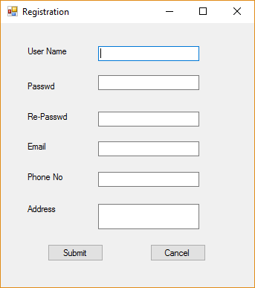

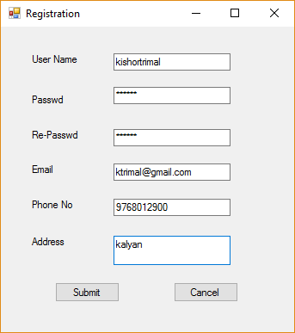

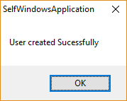

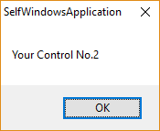

Case 2: Checking validation

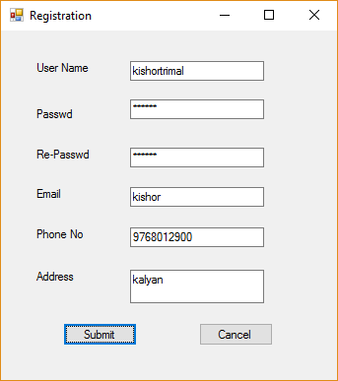

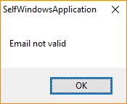

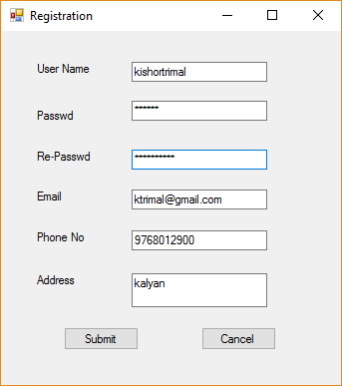

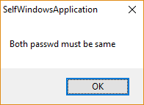

Case 3: Recovery Passwd

